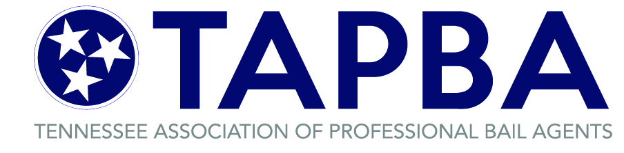

April 24, 2020

Chief Justice Jeffrey S. Bivins
Tennessee Supreme Court
Supreme Court Building, Suite 321
401 7th Avenue North
Nashville, TN 37219-1407

In Re: COVID-19 Rebuilding and Aftermath

Dear Chief Justice Bivins:

I hope that this letter finds you and your loved ones well. My name is Ernie Arredondo and I am the president of the Tennessee Association of Professional Bail Agents. My organization is the industry trade group representing the owners, agents and employees of the bonding companies that operate in every city and county across Tennessee. It is on the behalf of those individuals, totaling more than 2,500, that I am writing you today.

As you know, the private bail industry occupies a unique place in the criminal justice system. In the normal course of business, it serves the needs of both the State and the criminal defendants. However, these are not normal times. In the wake of COVID-19 and the response by local jurisdictions and the State, the bail industry has been hit especially hard.

Throughout this trying time, I have heard reports from my members that jails have refused to accept the surrender of criminal defendants with active warrants, to arrest them when they are found, and of jailers releasing defendants without bond. The professional bondsman is aware that we are in an unusual time, and that these decisions have been made with the best intentions to slow the spread of COVID-19. Nevertheless, we need to start planning for what happens next.

While the Court’s orders helped stabilize and provide guidance in the wake of the initial diagnosis, local jurisdictions have had a variety of responses to the epidemic. One aspect of the aftermath is clear however, it will take some time to get back to normal. I am asking that the Supreme Court, pursuant to

its authority, once again provide clear guidance to courts and clerks of this State by providing a uniform 180 days from the expiration of the Governor’s state of emergency before any action to take or enforce forfeits on behalf of the State. I believe that this is the minimum time necessary for courts to resume normal operations, for us to regain contact with our clients, and for the criminal defendants to once again become confident that they can resume their normal lives.

Without this stay, I anticipate that criminal defendants will be difficult to contact with new court dates. I also anticipate that many of them, being fearful of the risk of infection, have fallen out of contact with family members and friends, making tracking them difficult. They have lost employment and are seeking jobs where they can be found. The association believes that this time would allow the defendants, their family and friends some time to resume their normal lives before subjecting them and those close to them to the additional trauma of the uncertainty of missed court dates and obligations from forfeited bonds. I hope that you can give this proposal some consideration.

Thank you for your time and consideration.

Sincerely,
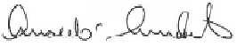
Ernie Arredondo, President
Tennessee Association of Professional Bail Agents

cc: Tennessee State Attorney General
President, District Attorney General’s Council

